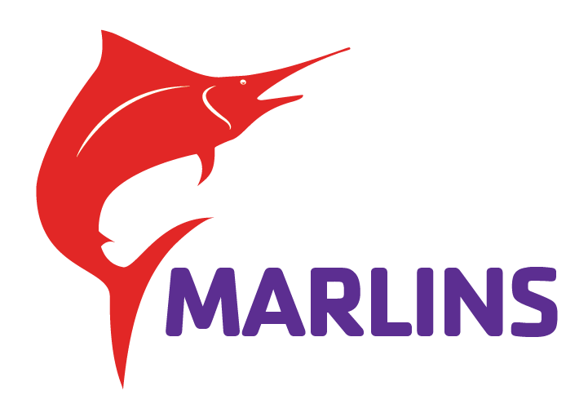
Swim Team Equipment
We are so excited for you to start your swim team adventure with our team! While swimming can be as simple as sliding on your suit and jumping in for practice, even the best athletes use a variety of equipment to help them improve their swimming skills.
Below is a list of required and recommended equipment that swimmers will need.
Required Equipment
Goggles
A good pair of swim goggles with your child’s name on them is essential and required for practice and meets!! They allow your child to open his/her eyes and not to swim blindly in the dark! For your younger children, they take a little getting used to, but please persevere; it will be well worth it.
A few notes when looking at goggles:
- Please avoid goggles made with tempered glass. While they sound fancy and elite, they still pose a risk of breaking and shedding glass in the pool.
- Competition vs. Recreational goggles – competition goggles are made with smaller lenses and gaskets to minimize drag (made for speed), while recreational goggles are made with larger lenses and softer materials. If your athlete struggles wearing goggles, consider looking at recreational goggles. As they get older and more comfortable with wearing them, consider switching to competition ones.
- If you are able, consider purchasing 2 pairs of goggles. While goggle straps can be adjusted as needed by the coaches, if something breaks there usually isn’t much that can be done to fix them.
- Recommended quality competition goggles: Speedo Vanquisher 2.0 (Adult & Jr), TYR Blackops Swimming Goggles, TYR Blackops Jr Swimming Goggles, Speedo Speed Socket 2.0 (Adult & Jr), or Arena Tracks Unisex Adult Essential Racing Swim
Swim Caps
Included in your registration is a team cap. Our team caps are made of silicone, allowing them to be more durable and minimize drag. During practice, swimmers can wear whatever swim cap they would like (fun artwork, slogans, colors), however during swim meets, there are rules about what kinds of caps can be worn.
During a swim meet, swimmers may only wear either their team cap or a solid color cap (no designs, patterns, slogans, etc.).
Caps will be handed out during practice. If a swimmer loses their team cap, a replacement can be purchased for $10.
Additional notes about swim caps:
- Latex caps have more flexibility and breathability than silicone. This makes them cheaper, but also more prone to tearing. Some individuals find latex easier to wear than silicone.
- We do have a small amount of latex style team caps for anyone who may prefer this alternative. Please make sure your swimmer does not have a latex allergy if you try this cap!
Recommended Equipment
The following equipment listed is RECOMMENDED to purchase – not required. If you elect to not purchase the listed equipment, we have a supply on deck for our athletes to use at practice.
You are welcome to purchase your equipment wherever you would like; however, we do have an online store set up at Swimoutlet.com to make it easy to purchase and with our recommendations on types of equipment.
Here is the direct link to our team store: https://www.swimoutlet.com/collections/shoreviewymarlins
Not all practice groups need the same equipment. Please see below what equipment is recommended for your group.
Practice Group | Kickboard | Swim Fins | Mesh Bag (to carry equipment) | Pull Buoy | Snorkel | Nose Plug | Hand Paddles
Novice | X | X | X
Age Group | X | X | X | X
Junior | X | X | X | X | X | X | X
Senior | X | X | X | X | X | X | X

The most important rule of equipment?
LABEL EVERYTHING!

